Release Assembly - TopCoder Cockpit Copilot Selection Update and Other Fixes Assembly Deployment Guide

Revision History
Author | Revision Number | Date
TCSASSEMBLER | 1.0 | 4/11th/2013

Deployment Instructions 3
1. Organization of Submission 3
2. Application Setup 3
2.1 Ant .Properties File 3
2.2 Configurations 3
2.3 Build Scripts Setup 3
3. Database Setup 4
3.1 Update and add queries via Query Tool 4
4. Deployment Instructions 4
5. Starting 4
6. Verification 4
6.1 Before starting verification 4
6.2 Verification steps 5
7. Resource Contact List 15

Deployment Instructions

Organization of Submission

The submission follows directory structure provided below:

doc
Contains the Deployment Guide Document of this assembly.

direct
Contains sources and static files for Direct web application. This directory replicates the application development distribution structure and includes only updated and new files.
queries
Contains 1 updated query
test_files
Contains the SQL files to insert test data

Application Setup

The application is expected to be deployed to the following environment:

JRE 1.5
JBoss 4.2.3.GA
Informix DS 11.5

Ant .Properties File

Configurations

N/A

Build Scripts Setup
The ANT build script for Direct application (build.xml) provides the following targets which are to be used:

- switch-and-checkout – checkout or switch to the defined source code branches for all components defined in subprojects.xml
- dist-backend – rebuilt all the components from the source code.
- first_deploy – must be the first task to execute from command line. It will copy all dependencies to your local JBoss folder.
- deploy – should be the main task to execute from command line. It will build and deploy WAR file.
- deploy-static-files – deploys the static files to JBOSS.
- deploy-apache-static – deploys the static files to apache server on VM.

Please refer here for more information:
http://www.topcoder.com/wiki/display/docs/TC+Direct+Setup+Guide

Database Setup
N/A

Update and add queries via Query Tool

Log into the TC Query Tool to update the provided 1 query
(On VM use http://tc.cloud.topcoder.com/query/query)

- TCS_CATALOG

Update query dashboard_cost_report
- Choose the database TCS_CATALOG
- Update query dashboard_cost_report with the content of queries/tcs_catalog/query_dashboard_cost_report.txt
- Save

Deployment Instructions

This section provides the instructions in Production environment.

- Merge the code from submission into SVN for Direct application including the backend component contest service façade
- Run ant dist-backend to rebuild all the backend components
- Build and deploy Direct application using ant deploy (or ant first_deploy ) command.
- Copy static files using ant deploy-static-files command or ant deploy-apache-static if use apache as static file server.

Starting

- Build and deploy the Direct application
- Start JBoss server instance hosting Direct application

Verification

Before starting verification
Set up test data first, run the following SQL scripts in order against the test server database:
- test_files/test_data.sql

Use various browsers to open the link http://localhost:8180/direct or https://[vm_ip]/direct/ , login as user / password.

Verification steps

As the test data is not fully correct on copilot posting, it's recommended to manually create a new copilot posting contest to test.

Verify TCCC-5152 Cockpit editing bug

Create a new draft software contest – for example a specification contest

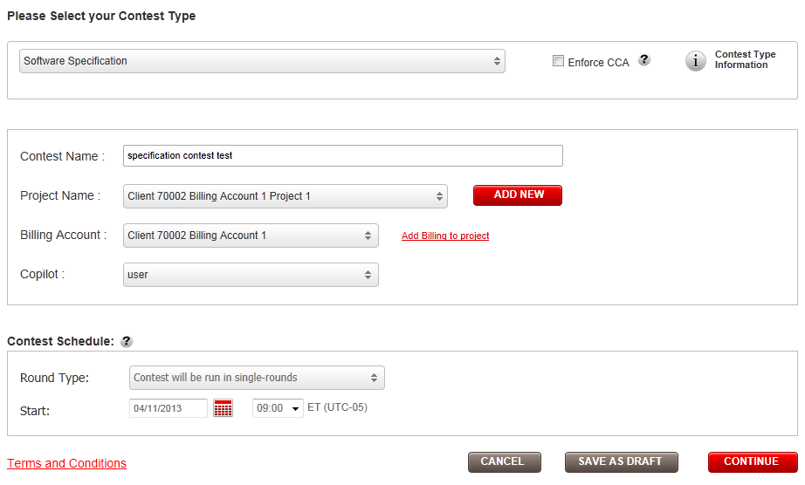

Save the draft contest and then following the View Contest button to go to the contest details page

Then open the prize edit panel

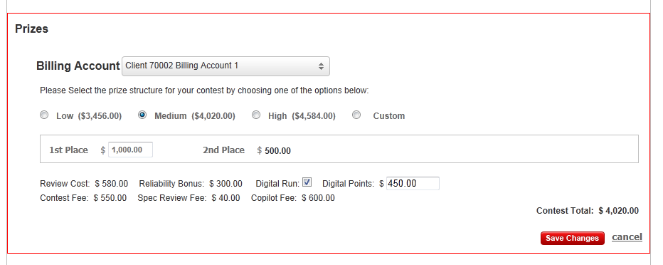

Choose custom prize and enter a number 2550 and save

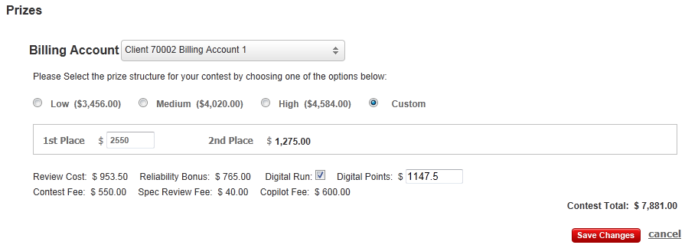

Open prize edit panel again to choose a different billing account

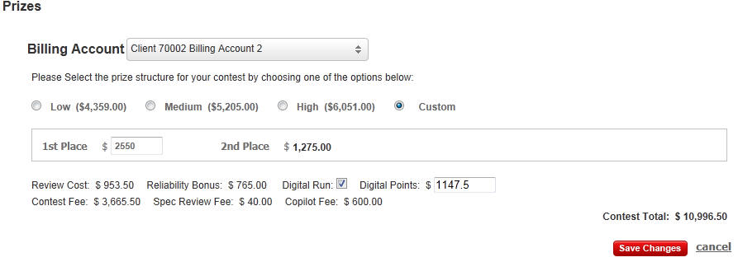
The prize is unchanged, but the contest fee is updated according to the different billing account configurations.

Continue to verify the flows when
- Low radio is chosen
- Medium radio is chosen
- High radio is chosen

Verify TCCC-5181 cost report options

Open the billing cost report

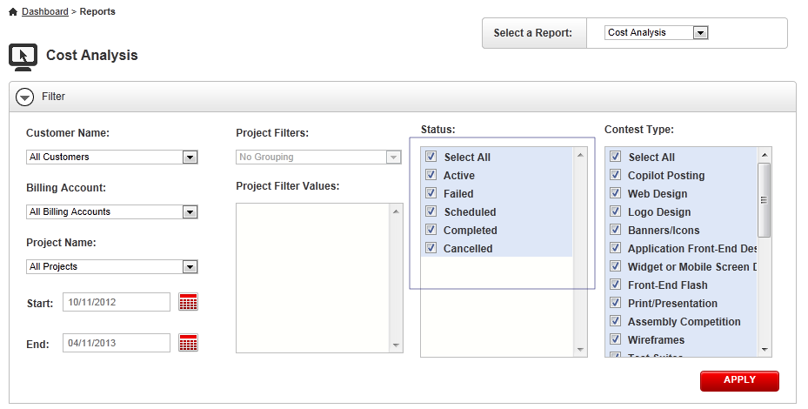

In the status multi-selection box, you will find there 5 status now

Chose a project to view its report

You can see different status are displayed on the report

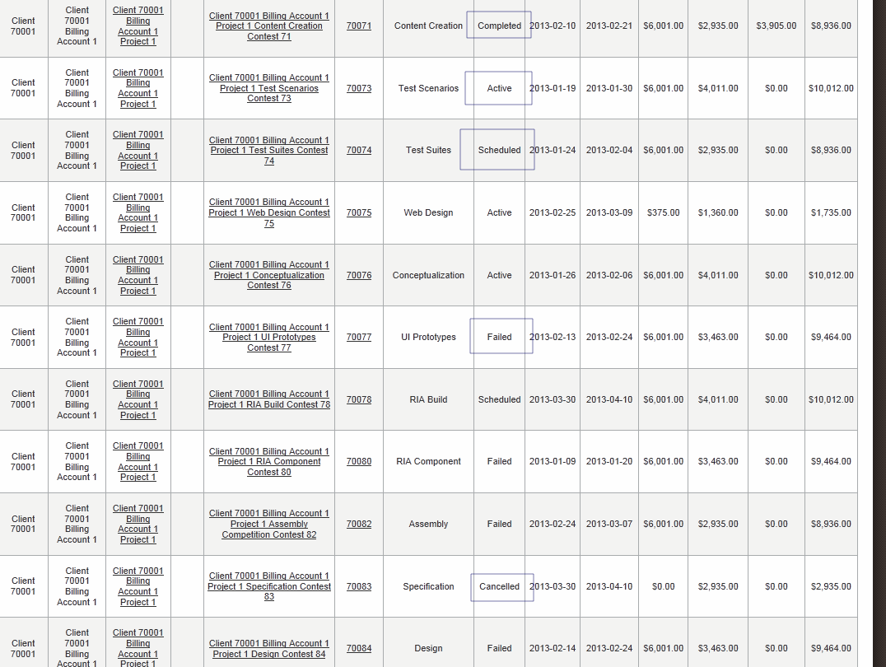

Verify TCCC-5210 Grant project permission when add resource metadata

This is already done in present code base

Open a test project to edit and you can see the permissions here

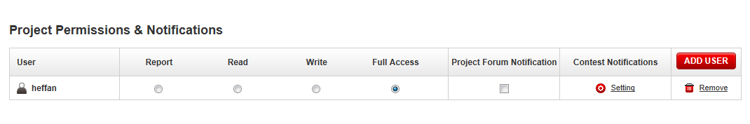

Add managers to the project, one manager one category

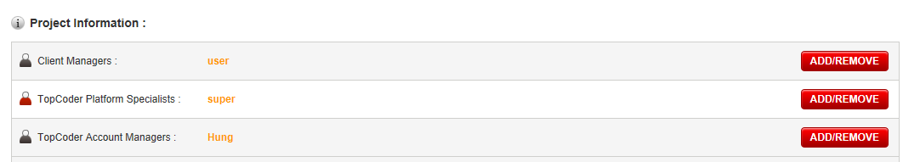

Refresh the edit project page, and check permission panel again

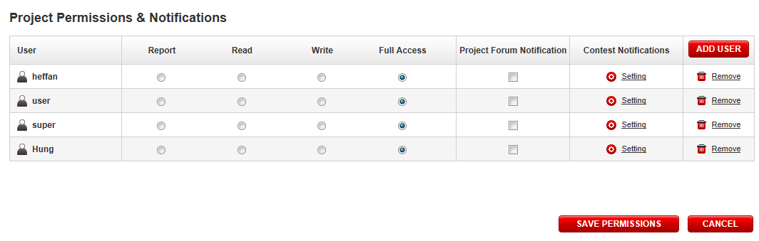

You can see these 3 added managers are all granted FULL ACCESS permission

Verify TCCC-5211 Copilot posting selection update

Create a copilot posting, activate it and move it to the review phase through online review

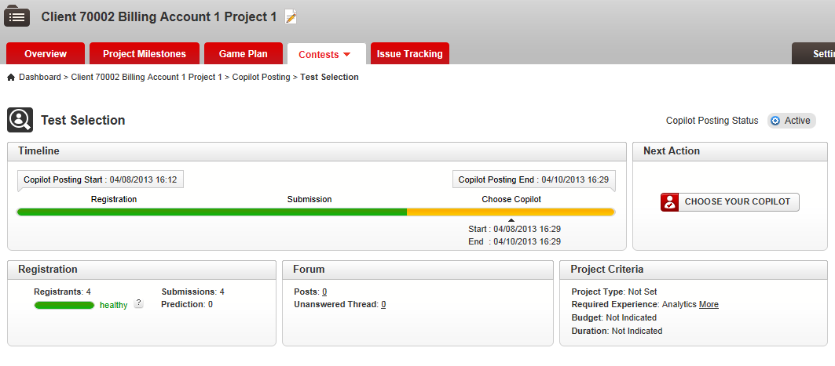

Open submission page, it defaults to list view

Choose the 1st place and 2nd place

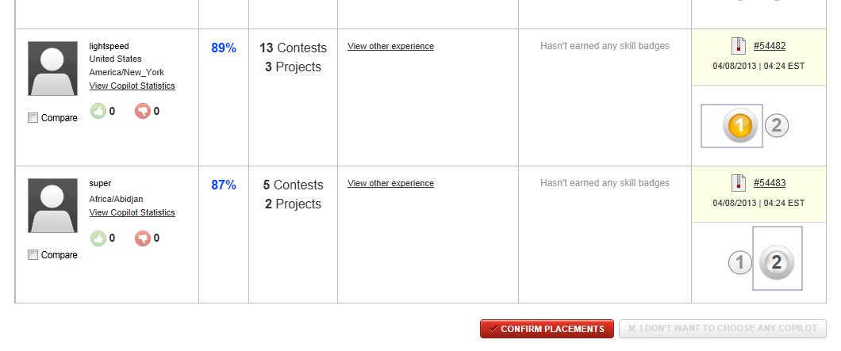

Click “CONFIRM PLACEMENTS” button – the ajax loading indicator will show and the after the ajax returns. These two copilots are marked like

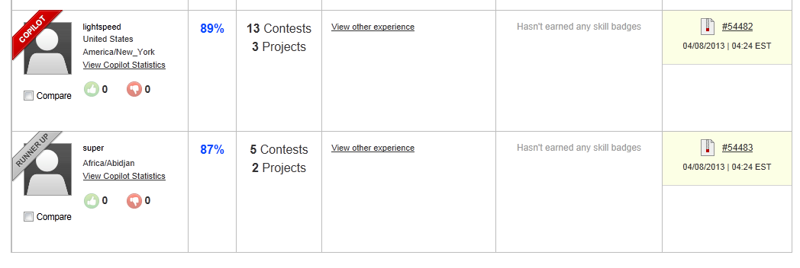

Refresh the page, you will see

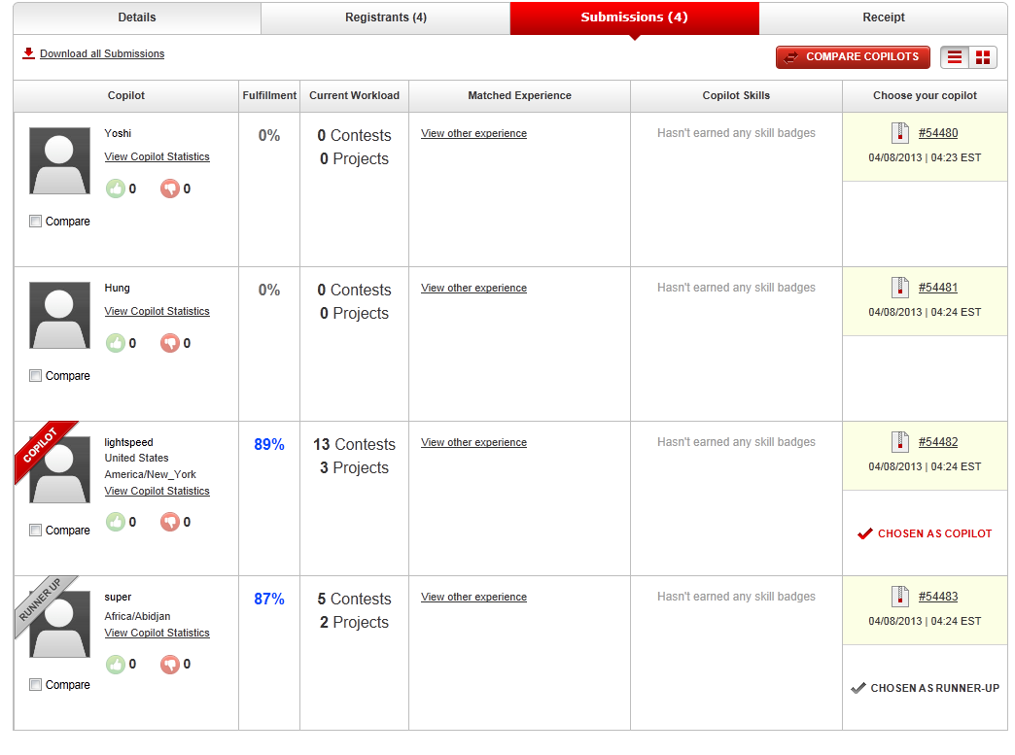

Removes the review by running

delete from review_comment where review_id IN
(select review_id from review where submission_id IN
(select s.submission_id from submission s, upload u where s.upload_id = u.upload_id and u.project_id = <contest id>));
delete from review_item_comment where review_item_id IN (select review_item_id from review_item where review_id IN (select review_id from review where submission_id IN
(select s.submission_id from submission s, upload u where s.upload_id = u.upload_id and u.project_id = <contest id>)));
delete from review_item where review_id IN (select review_id from review where submission_id IN
(select s.submission_id from submission s, upload u where s.upload_id = u.upload_id and u.project_id = <contest id>));
delete from review where review_id IN (select review_id from review where submission_id IN
(select s.submission_id from submission s, upload u where s.upload_id = u.upload_id and u.project_id = <contest id>));

And test again to only choose 1st place

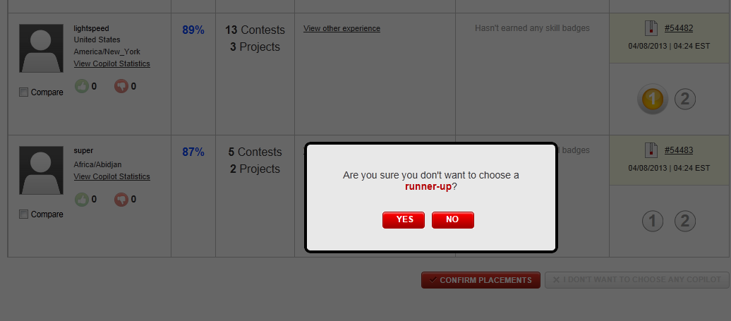

Click “YES”

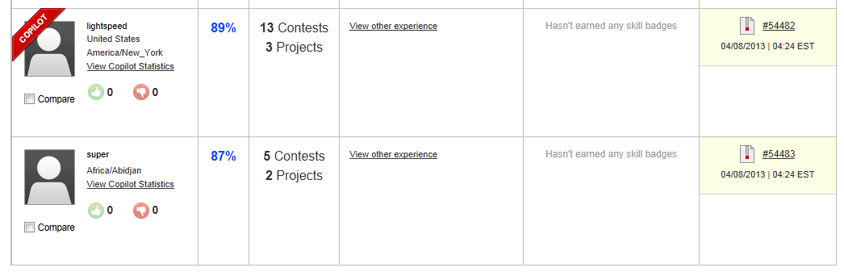

Removes the review and then test “I don’t want to choose any copilot”

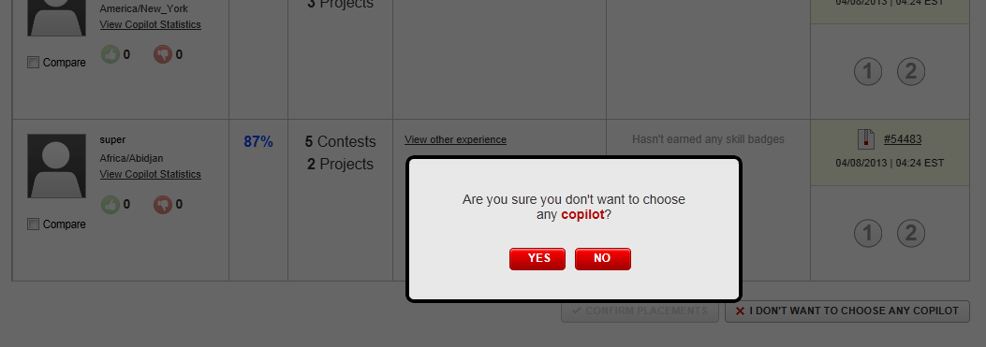

Click “YES”

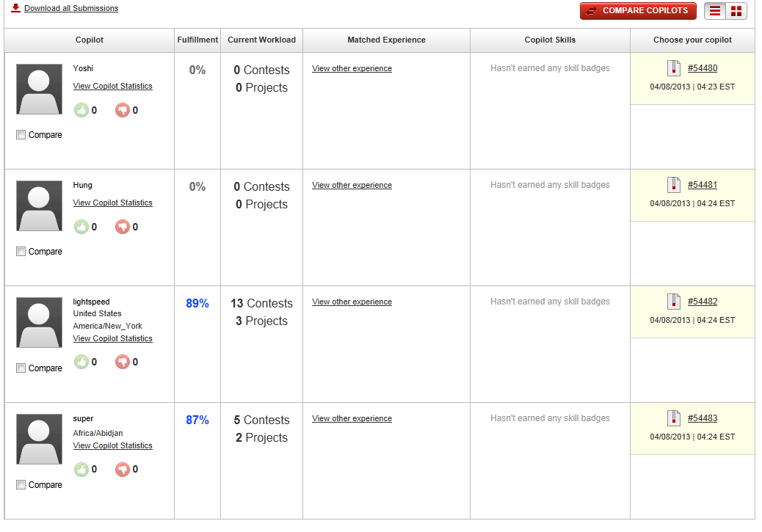

Removes the review then testing copilot comparison page – you can do the same to pick up copilots

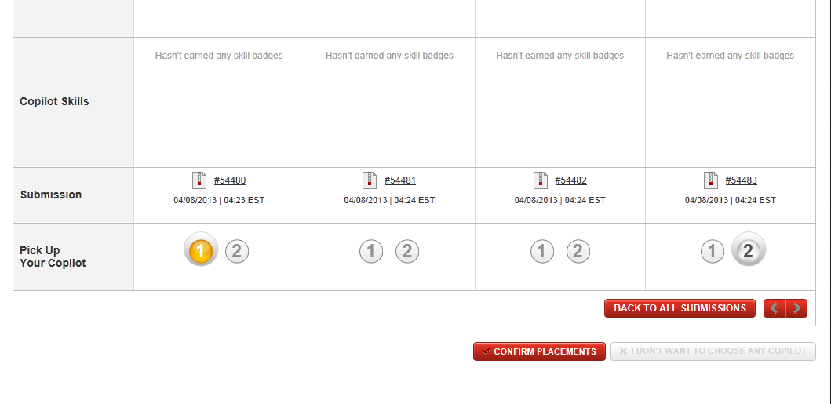

Verify TCCC-5215

Go the project overview page of the project tested in 6.2.3 – you can see
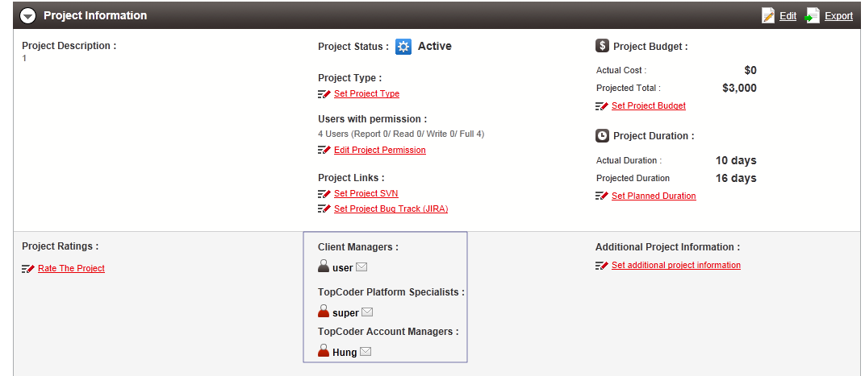

All the project resources have email icon which mailto link to the email address of the user

Verify TCCC-5223 Copilot Payment sub-tasks showing in game plan

The JiraRpcServiceWrapper is updated with new JIRA query, you can test the query in JIRA

String jqlQuery = (statusFilter != null ? ("(" + statusFilter + ") AND ") : "") + (jqlQueryBuilder.length() > 0 ? "(" + jqlQueryBuilder.substring(0, jqlQueryBuilder.length() - 3) +
") AND" : "") + " ((project=" + ConfigUtils.getIssueTrackingConfig().getBugRaceProjectName() + " AND issuetype!='Copilot Payment') OR issuetype='Client Task') order by Created DESC"

The old query is:
("Contest ID" ~ 30025052) AND ((project=BUGR) OR issuetype='Client Task') order by Created DESC

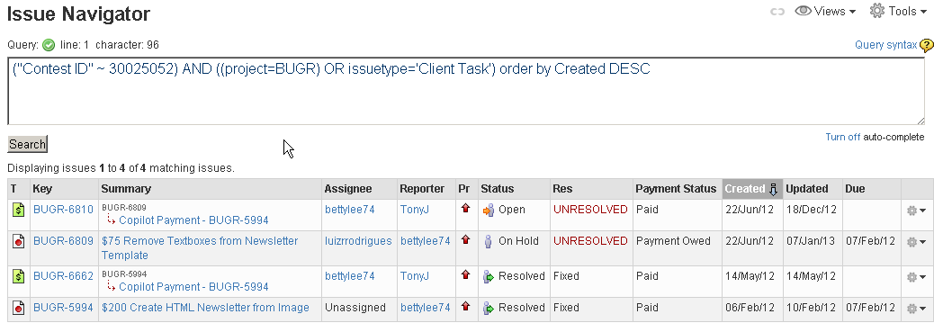

The result contains bug race copilot payment

The new query is:
("Contest ID" ~ 30025052) AND ((project=BUGR AND issuetype!='Copilot Payment') OR issuetype='Client Task') order by Created DESC

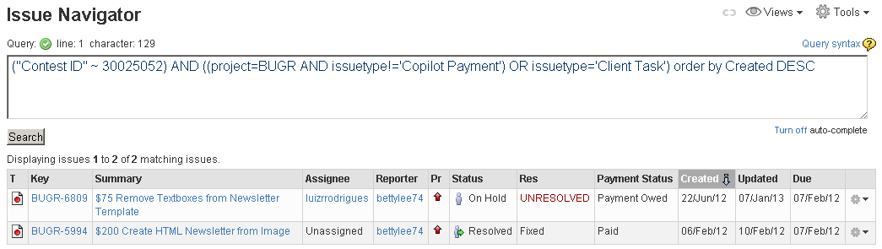

The copilot payment tickets are filtered out

Verify TCCC-5227

Login with an invalid password in the login page

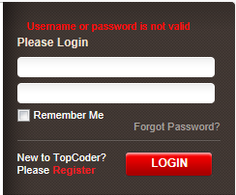

Resource Contact List

Name | Resource Email
TCSASSEMBLER

